**Convex quadrilateral**

A quadrilateral is a polygon in Euclidean plane geometry with four edges and four vertices. Quadrilaterals are either simple (not self-intersecting), or complex (self-intersecting, or crossed). Simple quadrilaterals are either convex or concave. This problem focuses on convex quadrilateral. A convex quadrilateral is a quadrilateral which has all interior angles less than 180 degrees and all the diagonals lie within the quadrilateral.

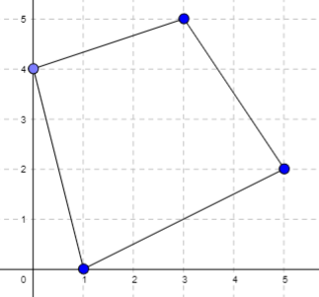 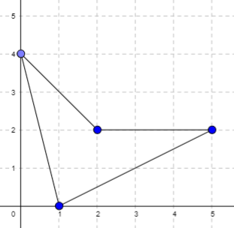

Figure 1. Left quadrilateral is a convex quadrilateral and right quadrilateral is not a convex quadrilateral

Given 4 points in 2D space, can they be the 4 vertices of a convex quadrilateral?

**Input:**

- Each test contains several test cases. The first line contains one integer number *t* (1 ≤ *t* ≤ 100) — the number of test cases..

- The first line of each case contains 8 integers *x*1,*y*1,*x*2,*y*2,*x*3,*y*3,*x*4,*y*4(-109 ≤ *xi, yi* ≤ 109) – coordinates of 4 points.

**Output:**

- For each test case, print “YES” if these point are the 4 vertices of a convex quadrilateral and “NO” otherwise.

**Sample:**

|  |  |
| --- | --- |
| **Input** | **Output** |
| 2  1 0 0 4 3 5 5 2  1 0 0 4 2 2 5 2 | YES  NO |